CST8218 Group **#6** Assignment

SOSTutors  
Status Report 2 (v0.2)

**Group Members:** Aboubacar Konde (040770799)  
 Harry Hidayat (040375590)  
 Jordan Gignac (040768816)  
 Muzammil Mirza (040746051)  
 Safi Naseem (040731978)

**Professor:** Douglas King  
 **Date:** 01 March 2016

# Introduction:

A *student* sometimes need help in the pursuit of knowledge. Sometimes the help provided by their school is not enough. One way of getting extra help is to hire a private tutor. A *tutor* is someone who is knowledgeable who can help students understand the more difficult ideas around a particular subject.

# Project plan

For our initial submission we had the following goals:

## 0.2

* Fixes bugs that came up during initial conception. (Jordan Gignac).
* Improve Database (Aboubacar Konde).
* Implement Database (Harry Hidayat).
* Design the Calendar (Muzammil Mirza).
* Start to develop the Calendar (Safi Naseem).
* Add Registration logic (Jordan Gignac).
* Add Login logic (Harry Hidayat).
* Add Search Tutors logic (Aboubacar Konde).
* Begin implementation of the booking system (Muzammil Mirza).
* Localization in GUI and extra database fields for multiple languages.

**Updated**: For 0.2 we went off track with our commitments. We have yet to design and implement the calendar, the booking system and the overall look and feel of the GUI.   
As per instruction we have implanted localization that was not In our goal for 0.2. We have also changed a few of the backend process such as login and registration.

The problems we encountered are mostly time constraints, with many of ours courses have midterms and assignments due. The conflicts basically stalled us as a group. While non-collaborative assignments in other courses were manageable, we have yet to be able work as efficiently in a group setting.

We believe we could will a demo-able prototype by Tuesday.

# Architecture

## Data Aspect

The server files (including database) will be stored on a machine(server) running Apache Tomcat.

User data such as user credentials and passwords will be stored in a MySQL database. The database structure will initially have this structure. The design has not been tested or implemented and might change over development.

MySQL  
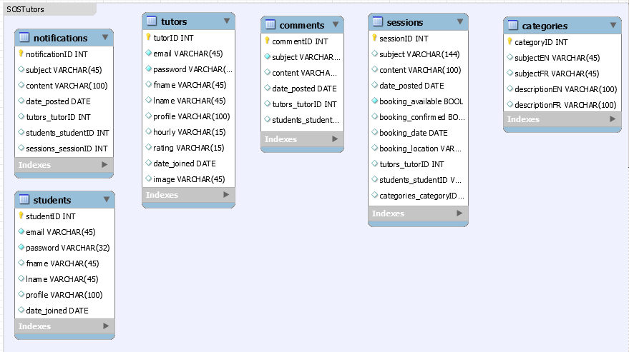  
/Documents/Database/SOSTutor.sql – Harry Hidayat  
**Updated**: Database is implanted in a basic manner. The tables are now basically self-contained with no relations to each other. Some of our members have had difficulties inserting canned data in tables with constraints and foreign keys. We added fields to implement multiple languages.

## Look And Feel

The web site will use CSS to change its look and feel, such as flat buttons, flat table borders, etc. The website will be rendered within the browser using HTML and Javascript.   
  
  
CSS  
styles/styles.css – Jordan Gignac   
  
JSP MAIN PAGES  
Contact.jsp - Aboubacar Konde  
About.jsp - Muzammil Mirza  
Tutor.jsp - Safi Naseem  
TutorSearch.jsp – Jordan Gignac  
Index.jsp - Harry Hidayat

Lang.jsp – Harry Hidayat  
  
JAVA PAGES  
DBConnector.java – Jordan Gignac  
Login.java – Safi Naseem  
Register.java – Muzammil Mirza  
Student.java – Harry Hidayat  
LoginServlet.java – Aboubacar Konde  
RegisterServlet.java - Aboubacar Konde

JSP ERROR PAGES  
Exception.jsp - Aboubacar Konde  
404.jsp – Jordan Gignac  
408.jsp - Harry Hidayat  
500.jsp - Safi Naseem  
502.jsp - Muzammil Mirza  
504.jsp - Aboubacar Konde

En-FR Languages resourse  
Aboubacar Konde

## Next release

Because we went off track for 0.2, we will be working on the missing promised feature along with 0.3. We do foresee further complications and will have a better picture in the next few days.

## 0.3

• Bug fixes for registration logic (Aboubacar Konde).

• Bug fixes for login logic (Jordan Gignac).

• Bug fixes for database and localization addition (Harry Hidayat).

• Implementation of the Calendar (Muzammil Mirza).

• Implement the Booking system (Safi Naseem, Aboubacar Konde).

• Implement the email notification system using 3rd party service (Harry Hidayat).